

**AIRBNB Listing 2024 Analysis**

This Listing analysis gives an insight on prices of Private Rooms, Home/Apartment, Hotel Room and Shared Room that are listed on Airbnb in the state of USA. They have been segmented into neighbourhood groups of Brooklyn, Manhattan, Queens, Bronx and Staten Island. It also includes correlational analysis to understand the dependency of price based on different factors like reviews, room type, availability, etc. This analysis provides us an understanding of the Airbnb listed stays and helps us in deciding the best time and type of room to choose for the stay. Also, how the prices change based on time and locations. For more analysis and better understanding go through the document and the project file.

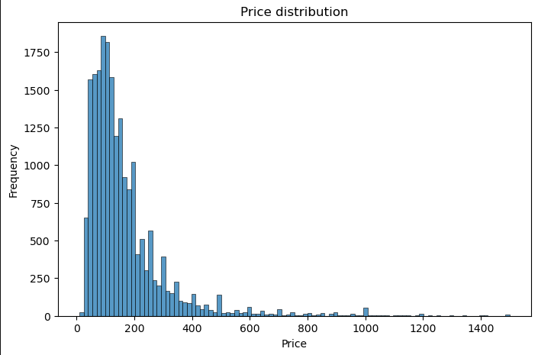 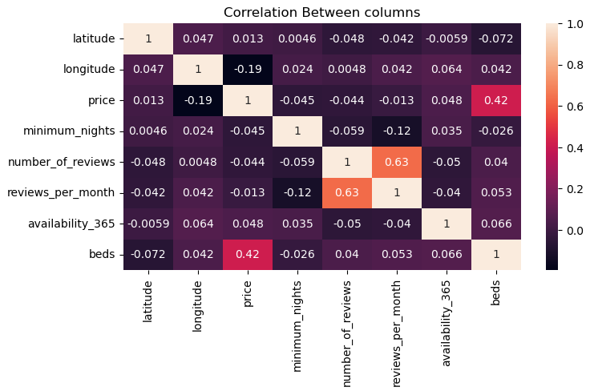 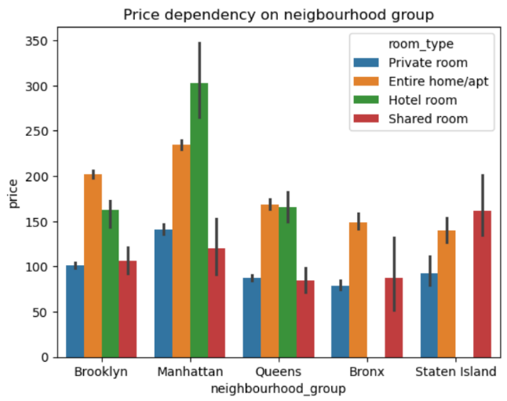

**Data Analysis and Visualization (EDA)**

**Univariate Analysis**

1. Price Distribution



*Insight - Most of the rooms are priced between $ 10 to 300*

1. Availability Distribution

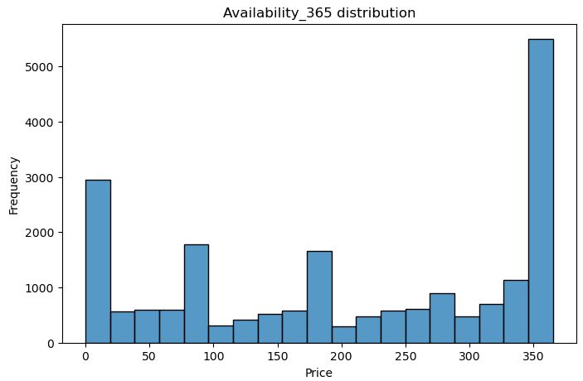

*Insight - Most of the rooms are available in the beginning and end of the year*

**Bivariate Analysis**

1. Comparison of price variance in different neighbour groups based on room type

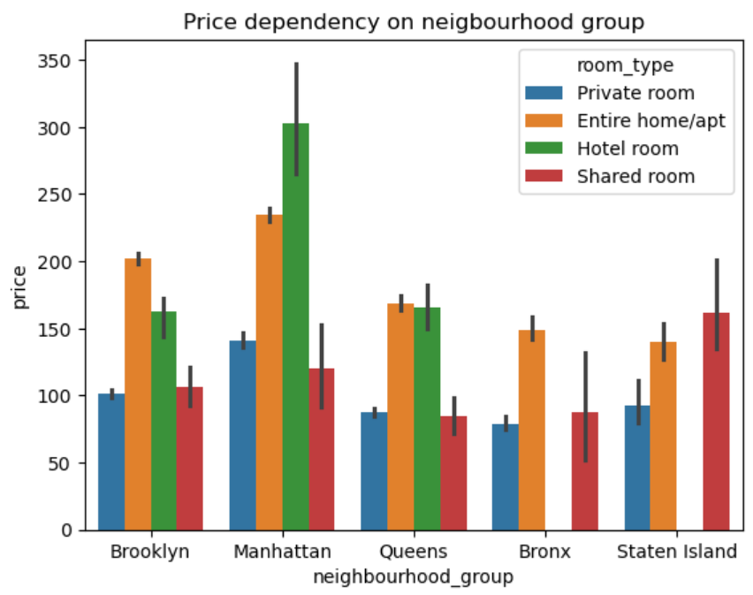

*insights:-*

1. *Brooklyn has Expensive Homes or Appartments but Cheaper Private Rooms*
2. *Manhattan has Expensive Hotel Rooms but Cheaper Shared Rooms*
3. *Queens has Expensive Homes or Appartments but Cheaper Shared Rooms*
4. *Bronx has Expensive Homes or Appartments bu Cheaper Private Rooms*
5. *Staten Island has Expensive Shared Rooms but Cheaper Private Rooms*
6. *We can say, on an average Private Rooms are Cheaper in all neighbourhood groups*
7. Comparison of Price dependency on reviews based on neighbourhood group

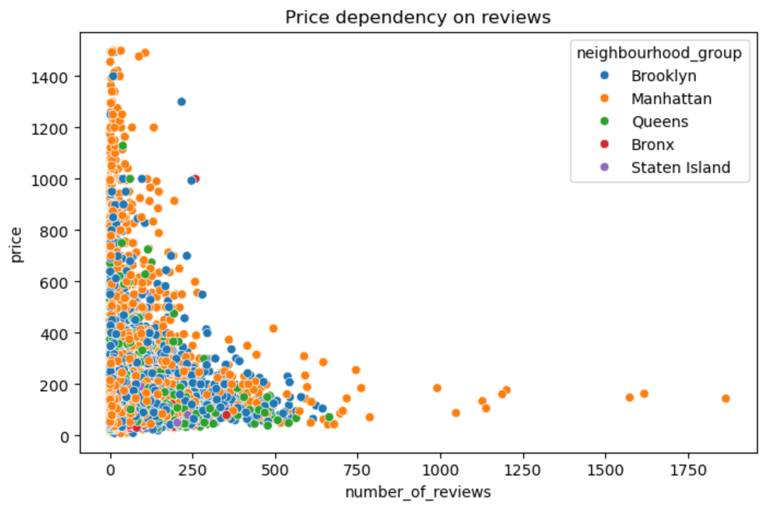

*Insight - There is negative correlation between Price and Number of Reviews*

1. Pairplots for Comparisons

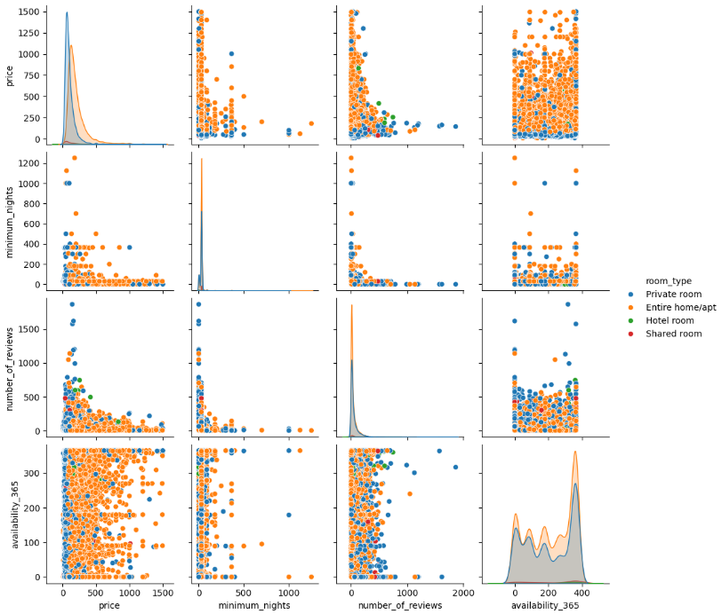

*Insight - Shows the Correlation between the selected Columns*

1. Geographical Distribution Based on Room Type

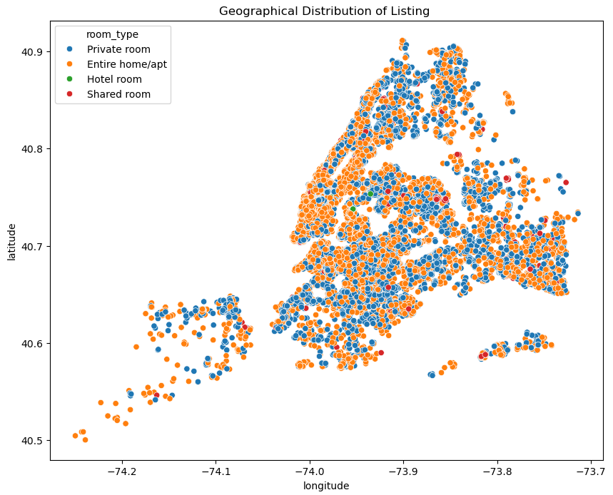

1. Geographical Distribution Based on Room Type



*Insight - Shows the correlation heatmap between every column*

**Conclusion**

We can conclude by saying that most of the rooms are priced between $10 and $300 and are mostly available during the beginning and the end of the year, also rooms in Bronx are most affordable. It is better to choose a Private Room in any state as it’s the cheapest option, prices do not depend on reviews, so look for room with better review.

**How to use.**

* Download the Folder named ‘AIRBNB Listing 2024 Analysis’.
* Unzip the file.
* Open the file named ‘AIRBNB Analysis’.